**EXPERIMENT 10**

**Aim:** To configure access points.

**Equipment:** Cisco Packet Tracer software

**Theory:**

The network layer is responsible for the delivery of individual packets from the source to the destination host. The packet transmitted by the sending computer may pass through several LANs or WANs before reaching the destination computer. For this level of communication, we need a global addressing scheme; which we call IP Address.

In computer networking, a wireless access point (WAP) is a networking hardware device that allows a Wi- Fi device to connect to a wired network. The access point usually connects to a router (via a wired network) as a standalone device, but it can also be an integral component of the router itself. An access point is differentiated from a hotspot, which is the physical location where Wi-Fi access to a WLAN is available.

A Router is a three-layer device which routes packets based on their logical addresses. A router normally connects LANs and WANs in the internet and has a routing table used for making decisions about the route.

**Procedure:** The following steps can be used to configure the access points:

**Step 1:** Select number of Laptops from Generic and Devices.

**Step 2:** Select two Access Points and a router from the Devices.

**Step 3:** Make Connections between the access points and a router through copper cross-wire.

**Step 4:** Connect Port 0 of both the access points to the router by selecting 0/0 and 1/0 ports of router respectively.

**Step 5:** Configure router with unique IP address using same class for different ports with the access points.

**Step 6:** Select each Laptop and replace the PT-Laptop-NM-1CFE with WPC300N in the physical view.

**Step 7:** Configure each Laptop with Unique IP Address using same class

**Step 8:** Configure each Laptop with Gateway Address of same class for same network to connect with the access points.

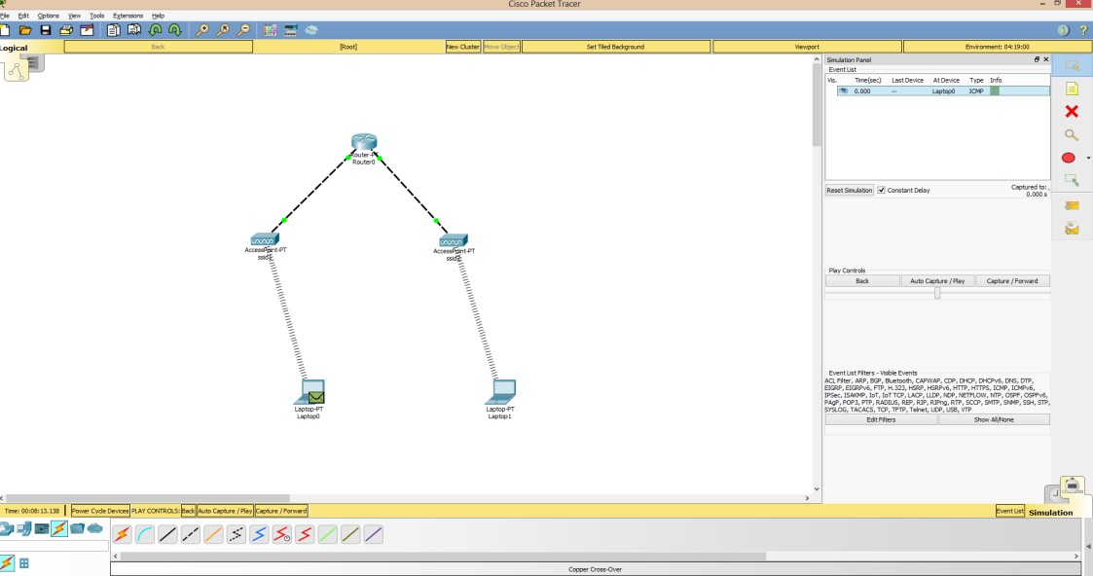

**Step 9:** Add simple PDU from Source Laptop to Destination Laptop.

**Step 10:** Click on the Simulation Mode Button which is on the right Bottom, and then simulate the Topology by clicking the Auto Capture/Play Button.

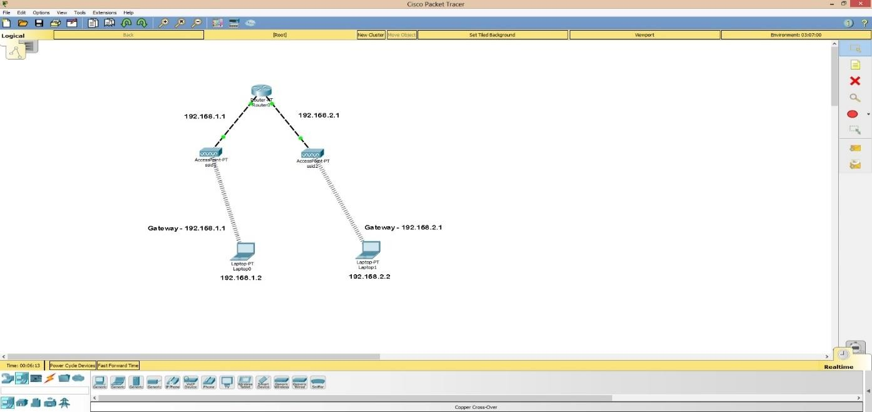

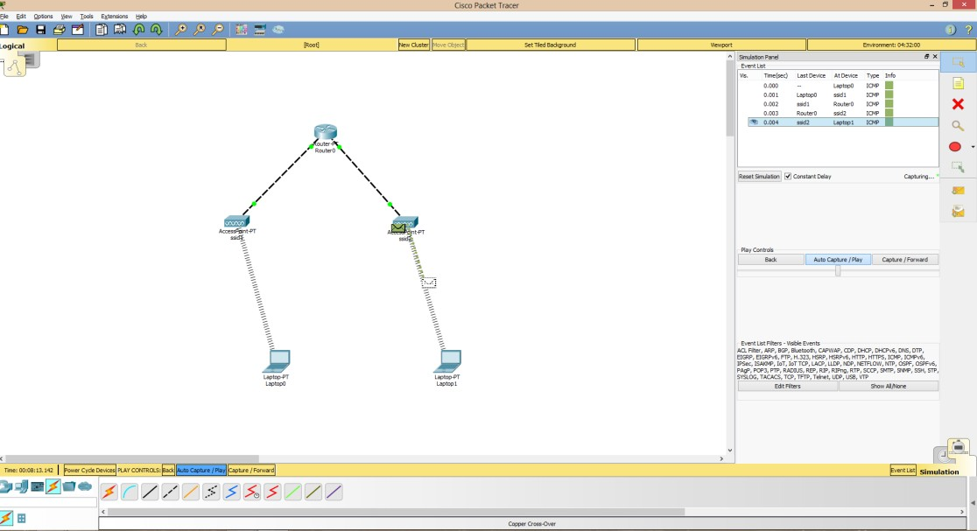

Sharing of a packet between two networks using access points and a router